An AI-Enabled Intelligent Study Assistant [Aura Learn] to enhance Student Learning Outcomes
Affect and Attention-Aware Emotion Detection Module

R26-SE-022

Project Proposal Report
K.K.G.Y. Mihiraj – IT22224552

B.Sc. (Hons) Degree in Information Technology Specialized in
Software Engineering

Department of Software Engineering
Sri Lanka Institute of Information Technology Sri Lanka

March 2026

ABSTRACT
The modern educational platforms are increasingly using Artificial Intelligence (AI) techniques for supporting the learning process and managing the workload of the students. However, despite the advancements in the learning platforms, the existing academic support systems cannot take into consideration the most important factor in the learning process of the students, i.e., the emotional and cognitive state of the students. Although there have been attempts in the past to introduce emotion-aware tutoring systems, they are often seen to face challenges such as the integration of the proposed systems, the computational overhead of the devices, and the ethical concerns of the storage of the sensitive facial images of the students. Therefore, in the present study, the researchers propose a new module of the Smart Study Assistant, i.e., the Affect and Attention-Aware Emotion Detection module, which is designed to overcome the challenges of the existing academic support systems. The proposed module is designed in such a way that it is able to overcome the challenges of the existing emotion-aware tutoring systems by using the secure distributed architecture of the proposed system, where the images of the webcams of the students are captured in an invisible manner through the web interface at an optimized frame rate of 20 frames per minute for the assessment of the emotional state of the students, such as frustration or confusion, as well as the assessment of the visual attention of the students.
The current study utilized a specialized microservice implemented using the Python programming language to process visual data completely in memory, using the capabilities of advanced computer vision. These computer vision capabilities enable the generation of low-dimensional effect and attention embeddings from the captured images, facilitating the analysis of the effect and attention. To ensure the highest level of ethical computing, the images captured by the system are immediately removed from the system's garbage collector once the embedding generation process is complete, meaning the images are never written to a database or disk. This enables the numerical embeddings to then be utilized as part of the application to dynamically adjust the schedules for the studies, optimize the presentation of the content, and schedule breaks for the studies. With these advancements, the proposed module hopes to improve the effectiveness of personalized learning, reduce cognitive overload, and create a framework for ethical and privacy-aware affective computing.
Keywords - Affective Computing, Emotion Detection, Eye Tracking, Privacy-Preserving AI, Intelligent Tutoring Systems, In-Memory Processing, Computer Vision, Educational Technology, Large Language Models, RAG, Hallucination Reduction, Confidence-Aware AI, Intelligent Tutoring Systems

ACKNOWLEDGEMENT

I would like to express my sincere gratitude to my supervisor, Mrs. Suriya Kumari, for her continuous guidance, valuable feedback, and encouragement throughout the development of this research proposal. Her insights and expertise have been instrumental in shaping the direction of my individual component.
I also extend my appreciation to my co-supervisor, Mr. Ravi Supunya, for his constructive suggestions and support during the early stages of this research.
My heartfelt thanks go to my project group members for their collaboration, discussions, and shared commitment toward achieving the overall objectives of our research project.
Finally, I am grateful to the Sri Lanka Institute of Information Technology (SLIIT) for providing the academic environment, resources, and learning opportunities that enabled me to undertake this research.

Table of Contents
1. INTRODUCTION 11
1.1 Background and Context 11
1.2 Literature Review 12
1.3 Research Gap 13
2. OBJECTIVE 14
2.1 Main Objective 14
2.2 Specific Objectives 14
3. METHODOLOGY 16
3.1 Research Approach 16
3.2 Emotion Detection Model and Feature Extraction Architecture 16
3.3 Tools and Platforms (with Justification) 20
3.4 Data Collection and Ethical Considerations 20
3.5 Validation Strategy and Performance Metrics 21
4. HIGH-LEVEL SYSTEM ARCHITECTURE 22
4.1 Overview of the Proposed Solution 22
4.2 System Components 25
4.3 Component Interactions 27
4.4 Data Flow Explanation 27
4.5 Scalability and Security Considerations 27
5. USER REQUIREMENTS 29
5.1 Stakeholder Identification 29
5.2 Functional Requirements 29
6. Commercialization Plan 31
6.1 Target Market and Customer Persona 31
7. BUDGET AND JUSTIFICATION 34
7.1 Hardware Costs 35
7.2 Software Licenses 35
7.3 Cloud Services 36
7.4 Human Effort Cost 37
7.5 Justification Summary 37
8. WORK BREAKDOWN STRUCTURE (WBS) 38
9. GANTT CHART 39
10. REFERENCES LIST 40

LIST OF FIGURES
Figure 1. real-time emotion detection workflow 19
Figure 2. High Level system diagram 25
Figure 3. Overall System Architecture 25
Figure 4. Work Breakdown Structure 39
Figure 5. Gantt Chart 40

LIST OF ABBREVIATIONS
Abbreviation | Full Form
AI | Artificial Intelligence
LLM | Large Language Model
RAG | Retrieval-Augmented Generation
NLP | Natural Language Processing
GPU | Graphics Processing Unit
FER | Facial Expression Recognition
LMS | Learning Management System
SDG | Sustainable Development Goal
DSR | Design Science Research
SaaS | Software as a Service
MOOC | Massive Open Online Course
HTTPS | Hypertext Transfer Protocol Secure
CNN | Convolutional Neural Network
QA | Quality Assurance
UI | User Interface
UX | User Experience
RAM | Random Access Memory
REST | Representational State Transfer
SSL / TLS | Secure Sockets Layer / Transport Layer Security

LIST OF APPENDICES

Appendices A. Risk analysis………………………………………………………………………………43

1. INTRODUCTION

1.1 Background and Context
The current university learning environment is characterized by substantial academic pressure on students, where they are expected to manage large volumes of learning materials, assignments, and examinations within limited timeframes. This demanding academic workload often leads to mental fatigue, increased anxiety, and reduced concentration levels among students. Studies indicate that academic stress and emotional challenges significantly affect students’ motivation, learning efficiency, and overall academic performance [1]. These challenges highlight the need for intelligent educational technologies that can support not only academic learning but also the emotional and cognitive well-being of students.
Current digital learning platforms, such as Learning Management Systems (LMS) and AI-powered study assistants, primarily focus on content delivery and study scheduling while largely ignoring the learner’s emotional and cognitive state. As a result, many learning systems generate static study recommendations that do not adapt to students’ fluctuating motivation or mental readiness. Recent research has attempted to integrate emotion detection into educational systems using artificial intelligence and computer vision techniques [2], [3]. However, many existing systems rely on manual self-reporting of emotions, which interrupts the learning workflow and reduces usability. Other approaches depend on continuous video processing on user devices, which introduces significant computational overhead and raises privacy concerns due to the storage or transmission of raw facial images [4].
To address these limitations, this research proposes an AI-enabled Smart Study Assistant designed to provide adaptive and emotionally aware learning support. The system integrates several intelligent components, including an LLM-based tutoring module, lecture summarization and flashcard generation, an adaptive study reminder system, and an affect-aware emotion detection module. Within this broader system architecture, the primary focus of this research is the Affect and Attention-Aware Emotion Detection Module, which aims to monitor students’ emotional and cognitive states during study sessions.
The proposed module introduces a lightweight and privacy-preserving emotion detection approach that combines facial expression analysis with eye behavior recognition. Instead of continuously processing video streams, the system captures periodic webcam frames and extracts features such as eye openness, blink rate, and gaze direction to estimate emotional and engagement states. These visual features are transformed into low-dimensional numerical embeddings that allow efficient machine learning analysis without storing identifiable facial data, thus addressing privacy and computational challenges commonly reported in existing approaches [5], [6].
The insights generated by this module are integrated with other components of the Smart Study Assistant to dynamically adjust tutoring responses, personalize study recommendations, and optimize reminder scheduling based on both academic progress and emotional readiness. By incorporating emotion- and attention-aware learning support, the proposed system aims to create a more personalized study environment that reduces cognitive fatigue and improves learning effectiveness. Furthermore, this research aligns with the United Nations Sustainable Development Goals, particularly SDG 4: Quality Education and SDG 3: Good Health and Well-being, while contributing to the Technology Integration and Management (TIM) research cluster within the Software Engineering specialization.

1.2 Literature Review
Recent developments in intelligent educational technologies have explored the use of artificial intelligence and computer vision to assess students’ emotional and cognitive engagement during learning activities. Emotion recognition and attention monitoring have become important research areas in the design of affect-aware intelligent tutoring systems, as emotional states such as frustration, boredom, and confusion significantly influence learning effectiveness [1].
Facial expression analysis for the detection of emotional states of students has been addressed by several research works. Deep learning methods, such as Convolutional Neural Networks (CNNs), are used to classify facial expressions into various emotions such as happiness, sadness, and anger, along with neutral expressions [2], [3]. However, these methods involve continuous video analysis, which might not be feasible for personal devices such as student laptops.
To further enhance the analysis of engagement, some researchers have attempted to combine emotion recognition with eye-tracking. Eye movements, blinks, and direction of the eyes have shown promising results as indicators of attention and cognitive engagement. Research conducted with eye-tracking-based approaches has shown improved detection of levels of concentration and mind-wandering compared to single-source-based approaches [4], [5].
However, many of the existing approaches rely on the use of video streams, which often involve computationally expensive deep learning-based approaches. As a result, they may incur processing costs and latency. Furthermore, many approaches store or transmit the original facial images, which is a major concern from the perspective of privacy and ethical use of biometric data [3].
To address these challenges, recent research has explored privacy-preserving techniques such as low-dimensional feature embeddings and federated learning frameworks. These methods aim to extract meaningful behavioral insights without retaining identifiable facial data [6]. However, many existing approaches focus on either facial emotion detection or eye gaze analysis independently, rather than integrating both modalities to provide a more comprehensive understanding of student engagement.

Author & Year | Method / Technology | Key Focus | Limitation
Subheesh et al., 2024 | CNN-based facial emotion detection | Detecting emotions from facial expressions in learning environments | High computational requirements
Vishnumolakala et al., 2023 | Eye tracking + emotion recognition | Measures student concentration and engagement | Require continuous video processing
Qarbal et al., 2025 | Deep learning with webcam data | Monitors engagement and posture during learning | Limited integration with adaptive educational systems
Wang et al., 2022 | Federated learning-based detection | Privacy-preserving behavioral analysis | Complex implementation
Vistorte et al., 2024 | AI-driven affect-aware tutoring analysis | Detects learner emotions and engagement | Limited real-time adaptive learning

1.3 Research Gap
Though tremendous changes have been made in the field of emotion recognition and engagement monitoring systems, there are a few limitations associated with the current systems, especially when they come to the educational domain.
Aspect | Existing Systems | Identified Gap
Learner State Analysis | Many systems detect emotions or engagement patterns but provide limited personalization for individual learners | Need for personalized emotional and cognitive state analysis tailored to individual learning behaviors
Detection Approach | Most systems detect disengagement only after behavioral changes become visible | Need for proactive real-time detection of early signs of fatigue, confusion, or frustration
Behavioral Scope | Existing approaches often analyze facial expressions or eye gaze independently | Need for integrated multimodal analysis combining facial emotion recognition and eye behavior
Computational Efficiency | Many emotion recognition systems rely on computationally expensive deep learning models and continuous video processing | Need for lightweight models suitable for real-time deployment on student devices
Privacy Protection | Several systems store or transmit raw facial images for emotion analysis | Need for privacy-preserving architectures that avoid storing facial data and instead use numerical feature embeddings

2. OBJECTIVE

2.1 Main Objective

To develop a light-weight emotion detection system, which would use periodic images captured by the webcam to analyze the facial expressions and eye movements of the students and then detect their emotional and engagement states during their studies. This would be achieved by using facial landmark detection and eye behavior analysis techniques, such as Eye Aspect Ratio, to obtain low-dimensional feature embeddings, thus reducing the computational complexities and avoiding the storage of raw images.

2.2 Specific Objectives
1. Development of a Periodic Webcam-Based Facial Data Capture System
- Design a webcam-based capture module capable of periodically capturing facial images (approximately 30 frames per minute) during student study sessions to monitor emotional and attention states without continuously processing video streams.
- Implement a facial landmark detection mechanism using MediaPipe Face Mesh, which provides 468 facial landmark points representing key facial regions such as the eyes, eyelids, eyebrows, and mouth.
- Detect and track eye regions and facial landmarks to enable further analysis of visual attention and emotional cues.
- Optimize the capture and preprocessing process to ensure minimal CPU and memory usage, making the system suitable for deployment on standard student laptops.
2. Implementation of Lightweight Feature Extraction and Emotion Classification
- Develop a feature extraction pipeline that converts facial landmark data into low-dimensional numerical features, including indicators such as eye openness, blink rate, eyebrow movement, mouth opening, and head tilt.
- Implement Eye Aspect Ratio (EAR) calculations using detected eye landmarks to determine blinking behavior and eye closure patterns, which are commonly used for fatigue and attention detection.
- Train and implement a lightweight machine learning model (e.g., Random Forest, Support Vector Machine, or a lightweight neural network) to classify students’ emotional states.
- Implement Focus emotion classification on a simplified set of learning-relevant emotional states such as focused, confused, frustrated, bored, and neutral, improving model efficiency and relevance for educational environments.

3. Integration of Multimodal Facial and Eye-Based Emotion Detection
- Combine facial expression analysis and eye behavior features to create a multimodal emotion detection mechanism that provides a more comprehensive understanding of students’ cognitive and emotional states.
- Integrate the extracted facial and eye-based features into a unified emotion classification pipeline capable of producing reliable emotion predictions in real time.
- Conduct Design the system architecture to support efficient feature fusion and rapid emotion inference while maintaining low computational complexity.
4. Privacy-Preserving Processing and System Evaluation
- Implement a privacy-by-design processing pipeline where captured images are analyzed in memory, converted into feature embeddings, and immediately deleted after feature extraction.
- Ensure that the system stores only non-identifiable numerical outputs such as emotion embeddings, attention scores, and timestamps.
- Evaluate system performance using metrics including emotion classification accuracy, attention detection reliability, computational efficiency, and processing latency.
- Conduct experimental testing under different environmental conditions such as lighting variations, camera positioning, and user diversity to ensure system robustness and fairness.

3. METHODOLOGY

3.1 Research Approach
This research adopts a Design Science Research (DSR) methodology, which is widely used in information systems and artificial intelligence research for designing and evaluating innovative technological artifacts. The objective of this research is to develop a lightweight and privacy-preserving emotion detection module capable of identifying students’ emotional and attention states during study sessions using facial expressions and eye behavior analysis.
The Design Science Research methodology is applicable because it is concerned with developing and testing a practical AI-based artifact to solve an authentic educational problem. The problem addressed is how to identify students’ emotional states during learning while ensuring privacy concerns are respected and computational overhead on students’ devices are minimized.
The research process follows several iterative stages including problem identification, system design, AI model development, prototype implementation, system evaluation, and refinement. During the evaluation stage, experimental methods will be used to assess system performance based on emotion classification accuracy, computational efficiency, and privacy compliance.

3.2 Emotion Detection Model and Feature Extraction Architecture
To identify students’ emotional and attention states efficiently, the proposed system uses a lightweight multimodal emotion detection model that combines facial expression analysis with eye behavior features.
1. Dataset Preparation and Model Training
The emotion detection model will be trained using publicly available facial emotion datasets such as:
- FER-2013
- RAF-DB
- AffectNet
- MPIIGaze
These datasets contain labeled facial expressions representing emotional states such as happiness, sadness, anger, and neutrality.
Data preprocessing techniques such as image normalization, resizing, and data augmentation (rotation, brightness adjustment, and scaling) will be applied to improve model generalization and robustness under different lighting conditions and camera angles.
Model training will be performed using cloud-based machine learning platforms such as Kaggle Notebooks or Google Colab, which provide free GPU resources for efficient deep learning experimentation. These platforms allow the model to be trained on large datasets without requiring expensive local hardware.
After training and evaluation, the final trained model will be exported and integrated into the local emotion detection module for real-time inference.
The model will be adapted to classify learning-relevant emotional states, including such as,
- Focused
- Confused
- Frustrated
- Bored
- Neutral
2. Facial Landmark Detection and Eye Behavior Analysis
To enhance computational efficiency, the proposed system makes use of facial landmark detection techniques. This is to avoid processing images of faces using computationally expensive deep learning models. This way, the proposed system can efficiently process facial movement using geometric features.
The proposed system makes use of the MediaPipe Face Mesh framework. This framework is used to detect 468 facial landmark points that relate to key areas of the face, including the eyes, eyelids, eyebrows, mouth, and facial contours. The proposed system is able to efficiently process facial expressions and eye behavior using these landmark points.
To process the movement of the eyes, the proposed system makes use of Eye Aspect Ratio values. The Eye Aspect Ratio is based on specific landmark points of the eyes. The Eye Aspect Ratio is used to calculate the relative distance between specific landmark points of the eyes. The Eye Aspect Ratio is used to measure the movement of the eyelids. This is an essential feature for a fatigue-detection-based student engagement level evaluation system because eyelids are a key feature of a person when it comes to fatigue.
The Eye Aspect Ratio is calculated as follows:
EAR = (||p₂ − p₆|| + ||p₃ − p₅||) / (2 × ||p₁ − p₄||)
where p₁–p₆ represent the landmark points surrounding the eye region.
Using this metric, the system can estimate:
- eye openness
- blink patterns and eyelid movement
- potential signs of fatigue or reduced attention
These features are widely used in fatigue detection and attention monitoring systems, making them suitable indicators for evaluating students’ engagement levels during study sessions.
3. Feature Vector Construction and Emotion Classification
Instead of processing raw images directly, the system converts facial and eye landmark data into low-dimensional numerical feature vectors.
Typical extracted features include:
- eye openness
- eyelid distance
- eyebrow movement
- mouth opening
- head tilt
- facial landmark distances
An example feature vector used for model training may include:
[eye openness, eyebrow distance, mouth opening, head tilt]
These numerical features are used as inputs for a lightweight machine learning classifier, such as:
- Random Forest
- Support Vector Machine (SVM)
- Lightweight Neural Network
This approach significantly reduces computational complexity compared to continuous image-based deep learning inference.
4. Periodic Webcam Data Capture
To reduce system overhead, the proposed system uses periodic sampling instead of continuous video processing.
A webcam-based capture module will collect approximately 30 facial images per minute during study sessions. This sampling strategy allows the system to monitor emotional states effectively while significantly reducing the number of frames processed.
Each captured frame is processed individually to extract facial landmarks and eye behavior features before being passed to the emotion classification model.
Compared to traditional video-based systems that process 30 frames per second (1800 frames per minute), the proposed sampling approach drastically reduces computational requirements while still capturing sufficient behavioral signals.
5. Real-Time Emotion Detection Pipeline
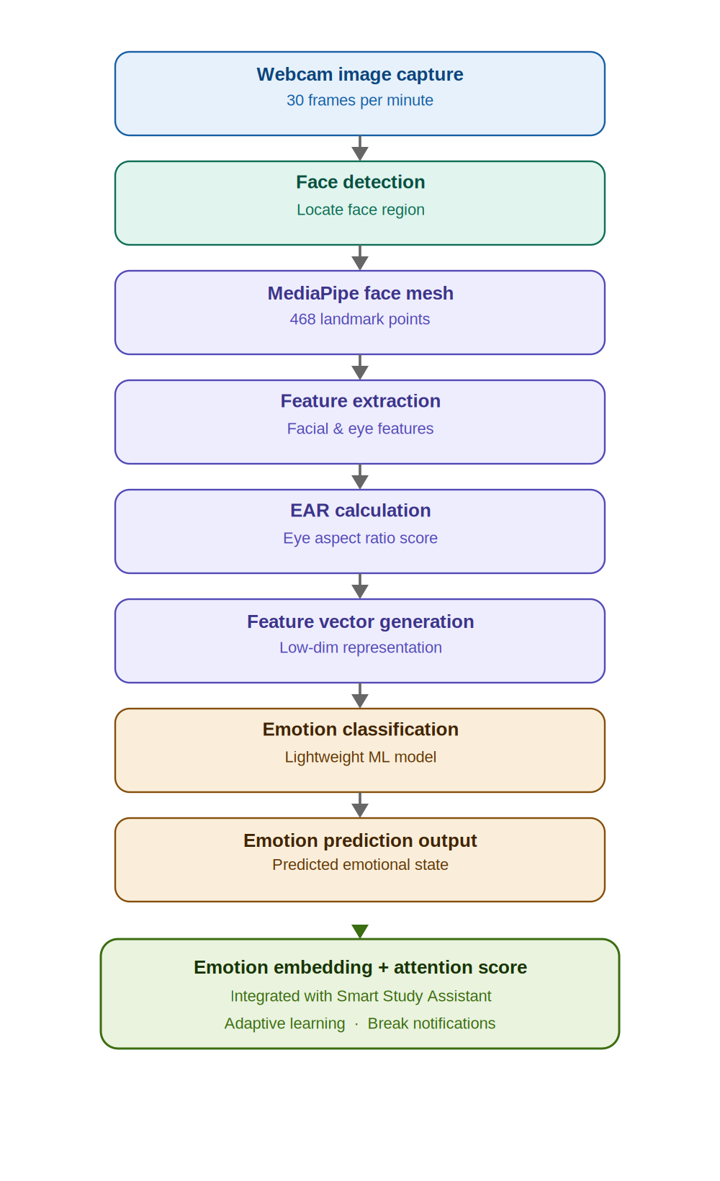
The real-time emotion detection workflow operates as follows:

Figure 1. real-time emotion detection workflow

The predicted emotional state is then converted into an emotion embedding and attention score, which can be integrated with the Smart Study Assistant system.

3.3 Tools and Platforms (with Justification)
Tool/Platform | Purpose | Justification
Python | AI model development | Widely used programming language for machine learning and computer vision research
Kaggle / Google Colab | Model training | Provides free GPU resources for training deep learning models efficiently
Scikit-learn / PyTorch | Model training and evaluation | Provides machine learning algorithms and tools for training emotion classification models
MediaPipe | Facial landmark detection | Lightweight framework capable of real-time facial landmark tracking
OpenCV | Image processing | Used for webcam capture and image preprocessing
Jupyter Notebook | Experimentation | Used for dataset preprocessing and model experimentation
GitHub | Version control | Supports collaboration and reproducibility
Web Browser (Webcam API) | Image capture | Enables periodic webcam capture directly from the student device

3.4 Data Collection and Ethical Considerations
Data Collection
The system utilizes two types of data sources.
Training Data
Publicly available facial expression datasets including:
- FER-2013
- RAF-DB
- AffectNet
- MPIIGaze
These datasets contain labeled emotional expressions used for training the emotion classification model.

Real-Time Inference Data
During active study sessions, webcam images will be captured at a controlled rate of approximately 30 frames per minute for real-time emotion detection. No captured images will be stored or retained after processing.
Ethical Considerations
The proposed system follows a privacy-by-design architecture to ensure responsible and ethical use of biometric data.
Key ethical principles implemented include:
- Zero Image Storage Policy: Raw facial images are never written on disk or stored in databases.
- In-Memory Processing: Captured images exist only temporarily during processing and are deleted immediately after feature extraction.
- User Consent: The system requires explicit user consent before accessing the webcam during study sessions.
- Data Anonymization: Only non-identifiable numerical outputs such as emotion embedding and attention scores are transmitted to the main system.
These mechanisms ensure compliance with ethical AI principles and protect student privacy.

3.5 Validation Strategy and Performance Metrics
Validation Strategy
- Emotion Detection Model Evaluation
Trained machine learning models will be tested using validation datasets to measure their ability to correctly classify emotional states under different environmental conditions such:
- varying lighting conditions
- different camera angles
- students wearing glasses
- System Performance Evaluation
The technical performance of the emotion detection module will be evaluated by measuring. This ensures that the system can operate efficiently on typical student devices.
- processing speed
- CPU usage
- memory consumption
- real-time responsiveness
- User Evaluation
A small-scale experimental study will be conducted with volunteer students to evaluate the practical usability of the system. Participants will use the system during short study sessions, and feedback will be collected regarding:
- system responsiveness
- perceived privacy protection
- impact on study workflow
Performance Metrics
Metric | Description
Emotion Classification Accuracy (%) | Measures the percentage of correctly predicted emotional states
Attention Detection Reliability | Accuracy of blink detection and eye behavior analysis
Computational Overhead | CPU and memory usage during system operation
Privacy Compliance Check | Verification that no raw images are stored during processing

4. HIGH-LEVEL SYSTEM ARCHITECTURE

4.1 Overview of the Proposed Solution
The proposed solution is a privacy-preserving and lightweight Affect and Attention-Aware Emotion Detection module designed to monitor students’ emotional and cognitive states during study sessions. This module functions as a component of the broader AI-Enabled Smart Study Assistant, operating as an independent subsystem responsible for detecting emotional signals and attention indicators based on facial expressions and eye behavior.
The system architecture is designed to achieve reliable emotion detection while maintaining low computational overhead, allowing it to run efficiently on standard student devices. Instead of continuously processing video streams, the system captures webcam frames periodically at controlled intervals (approximately 30 frames per minute). These frames are used to extract facial and eye behavior features relevant to engagement analysis.
Facial landmarks are detected using the MediaPipe Face Mesh framework, which identifies 468 landmark points representing key facial regions such as the eyes, eyelids, eyebrows, and mouth. These landmarks enable the extraction of important behavioral features including eye openness, eyelid movement, and facial expression patterns. In particular, the Eye Aspect Ratio (EAR) is calculated from eye landmarks to estimate eye openness and detect potential signs of fatigue or reduced attention.
To improve efficiency, the system converts the extracted facial and eye features into low-dimensional numerical feature vectors instead of processing raw images using computationally expensive neural networks. These features are then provided to a lightweight machine learning classifier, which categorizes the student’s emotional state into learning-related conditions such as focused, confused, frustrated, bored, or neutral.
To ensure user privacy, the system follows privacy by-design architecture. Captured images are processed temporarily in memory and immediately discarded after feature extraction. Only anonymous numerical embeddings and attention scores are transmitted to the main Smart Study Assistant system, ensuring that no raw facial data is stored or transmitted.
The system processes student facial data through the following pipeline:
- Periodic Webcam Image Capture
- Face Detection and Landmark Extraction
- Eye Behavior Analysis using EAR
- Feature Vector Generation
- Emotion Classification
- Emotion and Attention Output Generation
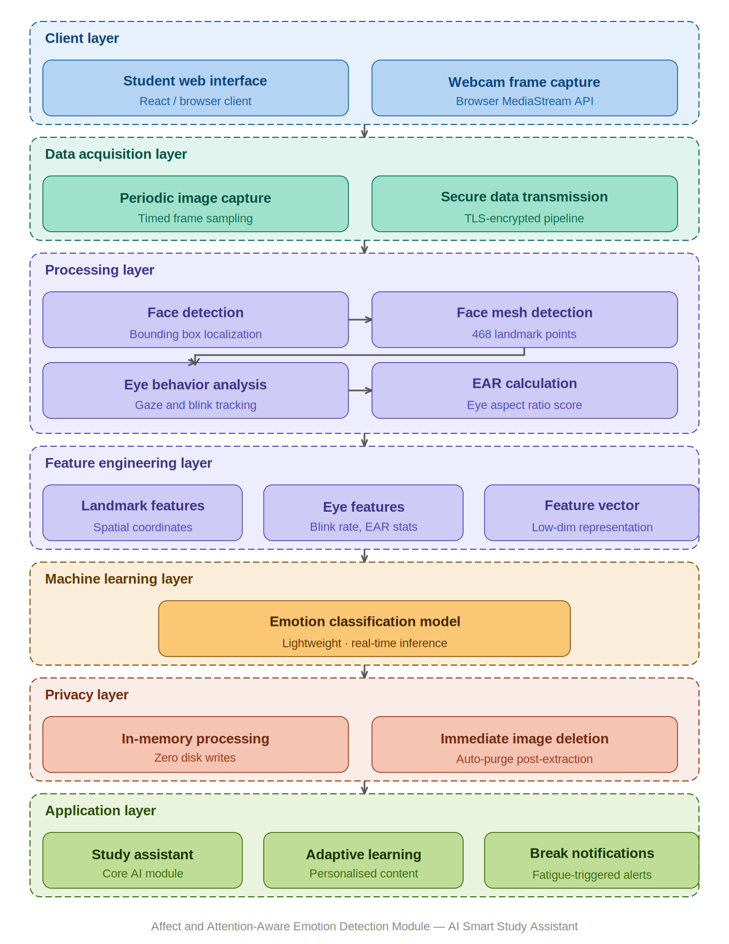
This architecture ensures efficient, privacy-safe emotion detection while minimizing computational requirements. Reference the diagram in the text as:
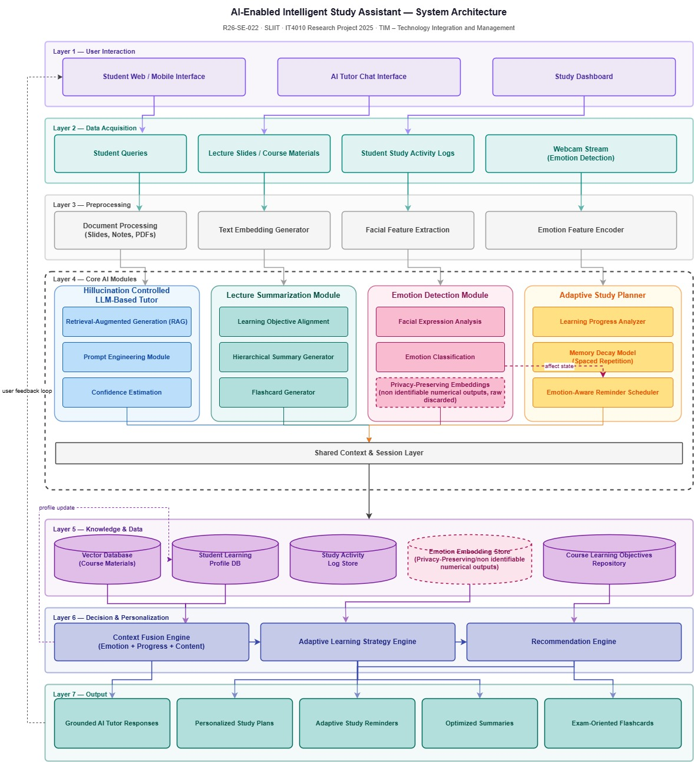
Figure 2. High Level system diagram

Figure 3. Overall System Architecture

4.2 System Components
1. Webcam Capture Layer
- Periodically captures facial images from the student’s webcam during study sessions.
- Captures images at controlled intervals (approximately 30 frames per minute) to reduce computational load.
- Ensures the capture process operates silently in the background without disrupting the user’s study workflow.
2. Face Detection and Landmark Extraction Layer
- Detects the student’s face from the captured image.
- Uses MediaPipe Face Mesh to identify 468 facial landmarks representing key facial regions.
- Extracts important landmark coordinates for facial regions such as:
    - eyes
    - eyebrows
    - mouth
    - facial contours
These landmarks serve as the basis for feature extraction.
3. Eye Behavior Analysis Layer
- Analyzes eye region landmarks to determine visual attention and fatigue indicators.
- Calculates the Eye Aspect Ratio (EAR) using eye landmark coordinates.
The EAR formula is defined as:
$$EAR=\frac{∣∣p2-p6∣∣+∣∣p3-p5∣∣}{2×∣∣p1-p4∣∣}$$
where $p1$–$p6$ represent key landmark points around the eye.
This calculation enables the system to measure:
- eye openness
- eyelid movement
- potential signs of fatigue or distraction

4. Feature Extraction Layer
- Convert facial landmarks and eye metrics into low-dimensional feature vectors.
- Examples of extracted features include:
    - eye openness
    - eyelid distance
    - eyebrow movement
    - mouth opening
    - head tilt

Example feature vector:
[eye openness, eyebrow distance, mouth opening, head tilt]
Using numerical features instead of full images significantly reduces processing complexity.
5. Emotion Classification Layer
- Receives feature vectors generated from facial and eye features.
- Uses a lightweight machine learning classifier such as:
    - Random Forest
    - Support Vector Machine (SVM)
    - Lightweight Neural Network
The classifier predicts the student's emotional state.
Emotion categories are simplified for learning environments:
- Focused
- Confused
- Frustrated
- Bored
- Neutral
6. Emotion Output Generation Layer
- Converts the predicted emotion into emotion embeddings and attention scores.
- Formats the output as structured data for system integration.
The output is then transmitted to the main Smart Study Assistant system to support adaptive learning features such as tutoring guidance and study reminders.

4.3 Component Interactions
The system operates through the following sequence of interactions:
- The webcam capture module periodically captures a facial image from the student.
- The Face Detection Layer identifies the student’s face and extracts facial landmarks using MediaPipe.
- The Eye Analysis Layer computes eye-related features such as eye openness using the EAR method.
- The Feature Extraction Layer converts facial landmarks into numerical feature vectors.
- The Emotion Classification Layer processes the feature vector using a trained machine learning model.
- The Emotion Output Layer generates emotion predictions and attention scores.
- The results are transmitted to the Smart Study Assistant system for adaptive learning support.
This interaction pipeline ensures efficient emotion detection with minimal computational overhead.

4.4 Data Flow Explanation
1. Input Flow
Webcam Image Capture → Face Detection → Facial Landmark Extraction
2. Processing Flow
Landmark Data → Eye Behavior Analysis → Feature Vector Generation
3. Decision Flow
Feature Vector → Emotion Classification Model → Emotion Prediction
4. Output Flow
Emotion Embedding + Attention Score → Smart Study Assistant System
This structured data flow ensures that emotion detection occurs efficiently while maintaining privacy and minimizing system resource usage.

4.5 Scalability and Security Considerations
Scalability
- The feature-based architecture reduces computational complexity compared to full video-based deep learning models.
- Lightweight machine learning models allow efficient deployment on standard student laptops.
- The modular design allows the emotion detection module to be integrated easily with other components of the Smart Study Assistant system.
Security and Privacy
- The system follows privacy-by-design architecture.
- Raw facial images are processed temporarily and immediately deleted after feature extraction.
- No facial images or biometric data are stored in databases or external storage.
- Only anonymous numerical outputs such as emotion embeddings and attention scores are transmitted to other system components.
- Webcam access requires explicit user consent before activation.
These measures ensure ethical AI implementation and protect student biometric data.

5. USER REQUIREMENTS

5.1 Stakeholder Identification
Stakeholder | Role | Interest / Responsibility
University Students | Primary users | Use the Smart Study Assistant during study sessions while the emotion detection module analyzes their emotional and attention states to support personalized learning.
Lecturers / Academic Staff | Educational stakeholders | Benefit from improved student engagement and learning effectiveness supported by adaptive learning systems.
System Developers / Research Team | Designers & implementers | Design, develop, train, test, and maintain the emotion detection module and integrate it with the Smart Study Assistant platform.
Research Supervisors / Evaluators | Quality assurance | Ensure the system meets research objectives, ethical guidelines, and academic standards.
University IT Department | Infrastructure support | Provide technical infrastructure and support for system deployment, maintenance, and integration with university platforms.

5.2 Functional Requirements
FR1 – Webcam Image Capture
- The system shall periodically capture facial images from the student’s webcam during study sessions.
- The system shall capture images at controlled intervals (approximately 30 frames per minute) to monitor emotional states without continuous video processing.
- The system shall request explicit user permission before accessing the webcam.
- The capture process shall operate in the background without disrupting the user’s study workflow.

FR2 – Face Detection and Landmark Extraction
- The system shall detect the student’s face from each captured image.
- The system shall extract facial landmarks using MediaPipe Face Mesh.
- The system shall identify key facial regions including the eyes, eyebrows, mouth, and facial contours.
- The system shall generate facial landmark coordinates required for feature extraction.
FR3 – Eye Behavior Analysis
- The system should analyze eye landmarks to determine visual attention indicators.
- The system shall calculate Eye Aspect Ratio (EAR) to estimate eye openness and eyelid movement.
- The system shall identify potential signs of reduced attention or fatigue based on eye behavior patterns.
FR4 – Feature Extraction
- The system shall convert facial landmarks into low-dimensional numerical feature vectors.
- The system shall extract features such as:
    - eye openness
    - eyebrow movement
    - mouth opening
    - head tilt
- The system shall prepare the feature vector as input for the emotion classification model.
FR5 – Emotion Classification
- The system shall classify the student’s emotional state using a trained machine learning model.
- The system shall support emotion categories relevant to learning environments, including:
    - Focused
    - Confused
    - Frustrated
    - Bored
    - Neutral
- The system shall generate an emotion prediction and attention score for each analyzed image.
FR6 – Output Integration
- The system shall convert the predicted emotion into emotion embeddings and attention scores.
- The system shall transmit the results generated to the Smart Study Assistant system.
- The system shall provide outputs in a structured format (e.g., JSON) for integration with other modules.

6. Commercialization Plan

6.1 Target Market and Customer Persona
Target Market
- Higher Education Institutions: Universities and institutes seeking reliable AI-based academic support tools.
- EdTech Companies: Platforms integrating intelligent tutoring or personalized learning features.
- Online Learning Platforms: MOOCs and digital academies requiring accurate, grounded AI explanations.
- Corporate Training Providers: Organizations offering technical upskilling programs.
Customer Persona
Name: Nethmi – 20-year-old undergraduate student
Goals: Understand complex topics, prepare for exams, get reliable explanations
Pain Points:
- AI tools giving incorrect or hallucinated answers
- Difficulty verifying information
- Lack of personalized academic guidance
Your system directly solves these issues by providing grounded, confidence-aware responses.
6.2 Value Proposition
Core Value
A highly reliable AI tutor that never gives unverified answers, reducing misinformation and improving learning outcomes.
Key Benefits
- Accuracy: All responses grounded in course materials.
- Trust: Confidence-aware mechanism prevents hallucinations.
- Personalization: Adaptive responses (answer, hint, clarification).
- Integration: Easily embedded into LMS platforms (Moodle, Blackboard, Canvas).
- Cost-Efficiency: Optimized RAG pipeline reduces inference cost.
Why Institutions Will Adopt It
- Enhances student performance
- Reduces lecturer workload
- Improves digital learning infrastructure
- Provides a competitive advantage in student support services

6.3 Revenue Model
1. Subscription Model (SaaS)
- Universities pay a monthly or annual fee based on student count.
- Includes updates, maintenance, and support.
2. Licensing Model
- One-time license for institutions wanting on-premise deployment.
- Additional customization fees.

3. API-Based Usage Model
- EdTech companies pay per API call or per 1,000 queries.
- Suitable for integration into third-party learning platforms.
4. Freemium Model (Optional)
- Basic features free for students.
- Premium features (analytics, multi-course grounding) available for a fee.

6.4 Cost Estimation
Development Costs
- Model hosting and compute
- Vector database infrastructure
- Backend/API development
- Testing and evaluation
Operational Costs
- Cloud hosting
- Model inference costs
- Maintenance and updates
- Customer support
Estimated Cost Breakdown
Cost Category | Estimated Cost (LKR)
Cloud compute & storage | 50,000 – 80,000 / month
Development & maintenance | 30,000 – 50,000 / month
Licensing & tools | 10,000 – 20,000 / month
Support & monitoring | 15,000 / month

6.5 Pricing Strategy
Tiered Pricing
- Basic Tier: Limited queries, single-course grounding
- Standard Tier: Multi-course support, adaptive responses
- Premium Tier: Full analytics, institution-wide deployment
Competitive Pricing
- Priced lower than global EdTech tools (Khanmigo, Chegg AI Tutor)
- Affordable for Sri Lankan and regional markets

6.6 Competitive Advantage
1. Confidence-Aware Response Control
Most AI tutors answer even when unsure.
Your system detects uncertainty and avoids hallucinations.
2. Course-Specific Grounding
Responses are tied to actual lecture materials, not generic internet knowledge.
3. Ethical and Transparent AI
Low-confidence responses trigger clarification instead of misinformation.
4. Modular Integration
Easily integrates into LMS platforms and existing university systems.
5. Local Market Fit
Designed for Sri Lankan and regional education systems, unlike global tools.

6.7 Intellectual Property Considerations
- The adaptive response mechanism, confidence-aware logic, and grounding enforcement pipeline can be patented as a novel AI tutoring framework.
- Course materials remain the property of the university; only embeddings are stored.
- Licensing agreements ensure institutions retain control over their academic content.
- The system complies with responsible AI guidelines and academic integrity standards.

7. BUDGET AND JUSTIFICATION
The following section presents an overview of the estimated costs required to design, develop, test, and evaluate the Affect and Attention-Aware Emotion Detection Module for the Smart Study Assistant system. The costs include hardware resources, software tools, cloud-based training environments, and human effort required to develop and evaluate the proposed system.
The proposed system utilizes lightweight machine learning models and open-source technologies, which reduces development costs while ensuring efficient performance of the proposed system.

7.1 Hardware Costs
Item | Estimated Cost (LKR) | Justification
Development Laptop / Workstation | 120,000 – 180,000 | Required for implementing the emotion detection system, testing computer vision algorithms, and running local experiments for feature extraction and inference.
External Storage (SSD) | 10,000 – 20,000 | Used to store datasets such as FER-2013, RAF-DB, AffectNet, trained models, and experimental results securely.
Webcam (if not built-in) | 5,000 – 10,000 | Required for capturing facial images during real-time system testing and evaluation.

Justification
Hardware resources are necessary for implementing the emotion detection module, performing experiments, and evaluating the performance of the system. A standard development laptop is sufficient because the system uses lightweight machine learning models and periodic image sampling instead of continuous video processing, reducing computational requirements.
External storage helps manage datasets, trained models, and research outputs, while a webcam enables real-time testing of facial expression and eye behavior analysis.

7.2 Software Licenses
Software / Tool | Estimated Cost (LKR) | Justification
Python Programming Language | Free | Primary programming language used for machine learning and computer vision implementation.
MediaPipe | Free | Used for facial landmark detection and extraction of facial features.
OpenCV | Free | Used for webcam capture, image preprocessing, and face detection.
Scikit-learn / PyTorch | Free | Used for training and implementing machine learning models for emotion classification.
Visual Studio Code | Free | Development environment is used for coding and debugging the system.
GitHub | Free | Used for version control, collaboration, and project management.

Justification
Most software tools required for this research are open-source machine learning and computer vision libraries, which significantly reduces the cost of development. These tools provide sufficient capabilities for implementing facial landmark detection, feature extraction, and emotion classification algorithms.

7.3 Cloud Services
Service | Estimated Cost (LKR) | Justification
Kaggle Notebooks / Google Colab | Free | Used for training the emotion detection model using GPU resources without requiring expensive local hardware.
Optional Cloud Storage | 3,000 – 5,000 / month | Used for storing datasets, trained models, and experimental outputs if remote storage is required.

Justification
Cloud-based platforms such as Kaggle Notebooks or Google Colab provide free GPU resources that enable efficient training of machine learning models using large facial expression datasets. This eliminates the need for expensive GPU hardware while allowing the research team to conduct deep learning experiments efficiently.
Cloud storage may optionally be used for storing datasets and trained models, particularly when collaborating with other research members.

7.4 Human Effort Cost
Role | Estimated Cost (LKR) | Justification
AI Engineer / Researcher | 50,000 – 80,000 | Designing RAG pipeline, uncertainty estimation, and adaptive response logic.
Backend Developer | 30,000 – 50,000 | Implementing APIs, integration, and system architecture.
QA / Tester | 20,000 – 30,000 | Testing hallucination rate, accuracy, and system reliability.

Justification
Human effort is required for system design, implementation, evaluation, and documentation. This ensures the solution meets academic and technical standards.

7.5 Justification Summary
Why These Costs Are Necessary
- Hardware enables efficient local development and experimentation.
- Software licenses ensure access to high-quality models and tools.
- Cloud services provide scalable infrastructure for hosting the LLM tutor.
- Human effort ensures the system is properly designed, tested, and validated.
Why the Budget Is Reasonable
- Most tools are open-source, reducing cost.
- Cloud usage is optimized through efficient RAG pipelines.
- Human effort cost reflects realistic academic development requirements

WORK BREAKDOWN STRUCTURE (WBS)

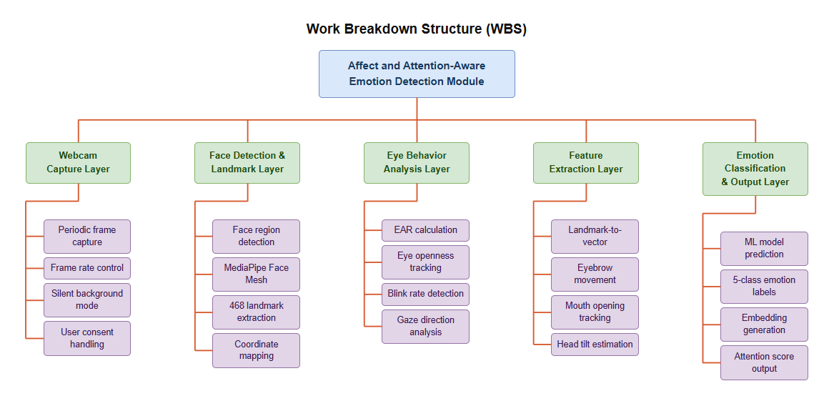
Figure 4. Work Breakdown Structure

GANTT CHART

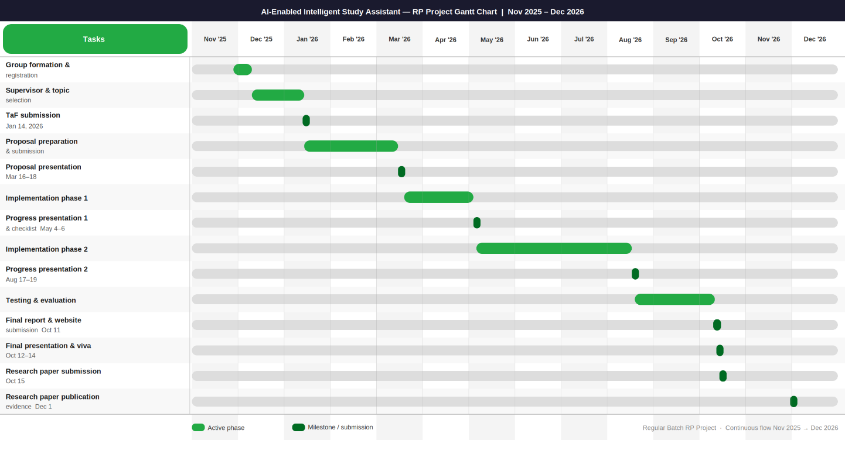
Figure 5. Gantt Chart

REFERENCES LIST
[1]
A. O. R. Vistorte, L. S. B. Ribeiro, M. A. S. Netto, and F. S. Osório, “Integrating artificial intelligence to assess emotions in learning environments: A systematic review,” Artificial Intelligence Review, vol. 57, no. 4, pp. 1–32, 2024.
[2]
N. P. Subheesh, M. B. Nair, and K. S. Kumar, “System for emotion and engagement recognition in education (SEERE),” in Proc. IEEE Frontiers in Education Conf. (FIE), 2024, pp. 1–8.
[3]
K. Sarvakar, R. Patel, and S. Shah, “Revolutionizing facial emotion recognition using deep learning techniques,” Journal of Intelligent Systems, vol. 34, no. 2, pp. 145–158, 2025.
[4]
Y. Cai, W. Li, and Z. Zhang, “Emotion recognition using different sensors: A comprehensive survey,” Sensors, vol. 23, no. 5, pp. 2455–2478, 2023.
[5]
S. Vishnumolakala, R. S. Rao, and A. K. Singh, “Eye-tracking based student engagement detection in online learning environments,” IEEE Access, vol. 11, pp. 56421–56434, 2023.
[6]
Y. Wang, H. Li, and J. Zhang, “Federated learning for privacy-preserving emotion recognition systems,” IEEE Access, vol. 10, pp. 113456–113468, 2022.
[7]
Piro, L., Bianchi, T., Alessandrelli, L., Chizzola, A., & Casiraghi, D. (2024). MyLearningTalk: An LLM-based intelligent tutoring system. Lecture Notes in Computer Science. DOI: 10.1007/978-3-031-62362-2_39
[8]
Akcora, D.E., Belli, A., Berardi, M., Casola, S., & Di Blas, N. (2018). Conversational Support for Education. In Artificial Intelligence in Education (pp. 15-25). Springer. DOI: 10.1007/978-3-319-93846-2_3
[9]
Thomas, C., & Jayagopi, D.B. (2017). Predicting student engagement in classrooms using facial behavioral cues. In Proceedings of the 1st ACM SIGCHI International Workshop on Multimodal Interaction for Education (pp. 33-40).
[10]
Dewan, M.A.A., Murshed, M., & Lin, F. (2019). Engagement detection in online learning: A review. Smart Learning Environments, 6(1), 1-20.

APPENDICES

11.1 Appendix A – Risk Analysis
The following table identifies the key risks associated with the development of the Affect and Attention-Aware Emotion Detection Module, along with their likelihood, impact, risk level, and proposed mitigation strategies.

ID | Risk Description | Likelihood | Impact | Risk Level | Mitigation Strategy
Technical Risks
R01 | Low emotion classification accuracy due to limited or biased training data | High | High | Critical | Combine FER-2013, RAF-DB, and AffectNet datasets. Apply data augmentation and use transfer learning.
R02 | MediaPipe landmark detection fails under poor lighting or low-resolution webcam | Medium | High | High | Add image brightness preprocessing. Set minimum resolution requirements and test under varied lighting.
R03 | High computational overhead causing lag on low-spec student laptops | Medium | High | High | Use lightweight classifiers (SVM, Random Forest). Limit frame capture to 30 fps. Profile on minimum-spec hardware.
R04 | In-memory image processing leaks facial data due to garbage collection delays | Low | High | High | Explicitly nullify image objects post-embedding. Call gc.collect() after each cycle. Run memory leak unit tests.
Privacy & Ethical Risks
R05 | Students unaware of webcam activation, leading to privacy or ethical violations | Medium | High | High | Require explicit opt-in consent before activation. Show a visible webcam-active indicator in the UI at all times.
R06 | Emotion labels misclassified as negative, causing student distress or loss of trust | Medium | Medium | Medium | Do not display raw emotion labels to students. Use emotional data only internally for adaptive adjustments.
Data & Research Risks
R07 | Insufficient labelled dataset for learning-specific emotion categories (Focused, Confused, Bored) | High | High | Critical | Use transfer learning from general datasets. Supplement with volunteer student data collected under ethics approval.
R08 | Model overfitting to training data, poor generalisation to real student population | Medium | High | High | Apply k-fold cross-validation, L2 regularization, and dropout. Evaluate on a held-out test set from a separate dataset.
Schedule & Resource Risks
R09 | Delays in ethics approval for student data collection extending project timeline | Medium | High | High | Submit ethics approval early. Use public datasets (FER-2013, AffectNet) as fallback to continue development in parallel.
R10 | Free GPU resources (Google Colab, Kaggle) unavailable during peak academic periods | Medium | Medium | Medium | Schedule training during off-peak hours. Keep portable training scripts ready for any available GPU platform.

Risk levels: Critical = High likelihood + High impact. High = Medium/High combination. Medium = Medium combination or Low/High mix. Low = Low combination. All risks will be monitored throughout the project lifecycle and reviewed at each milestone.

